Notification and Access Requirements Checklist
For Public Sector Employers
September 2023
__________________________________________

Notification and access requirements should be completed before the submission period closes on 31st October. Prior to this step, you should have already completed the following:
- Submitted the Questionnaire, Workforce Management Statistics and Workplace Profile
- Generated reports
- Obtained CEO or equivalent approval
- Declared and submitted report

See the checklist on the next page for a breakdown of the required actions to complete your notification and access requirements.

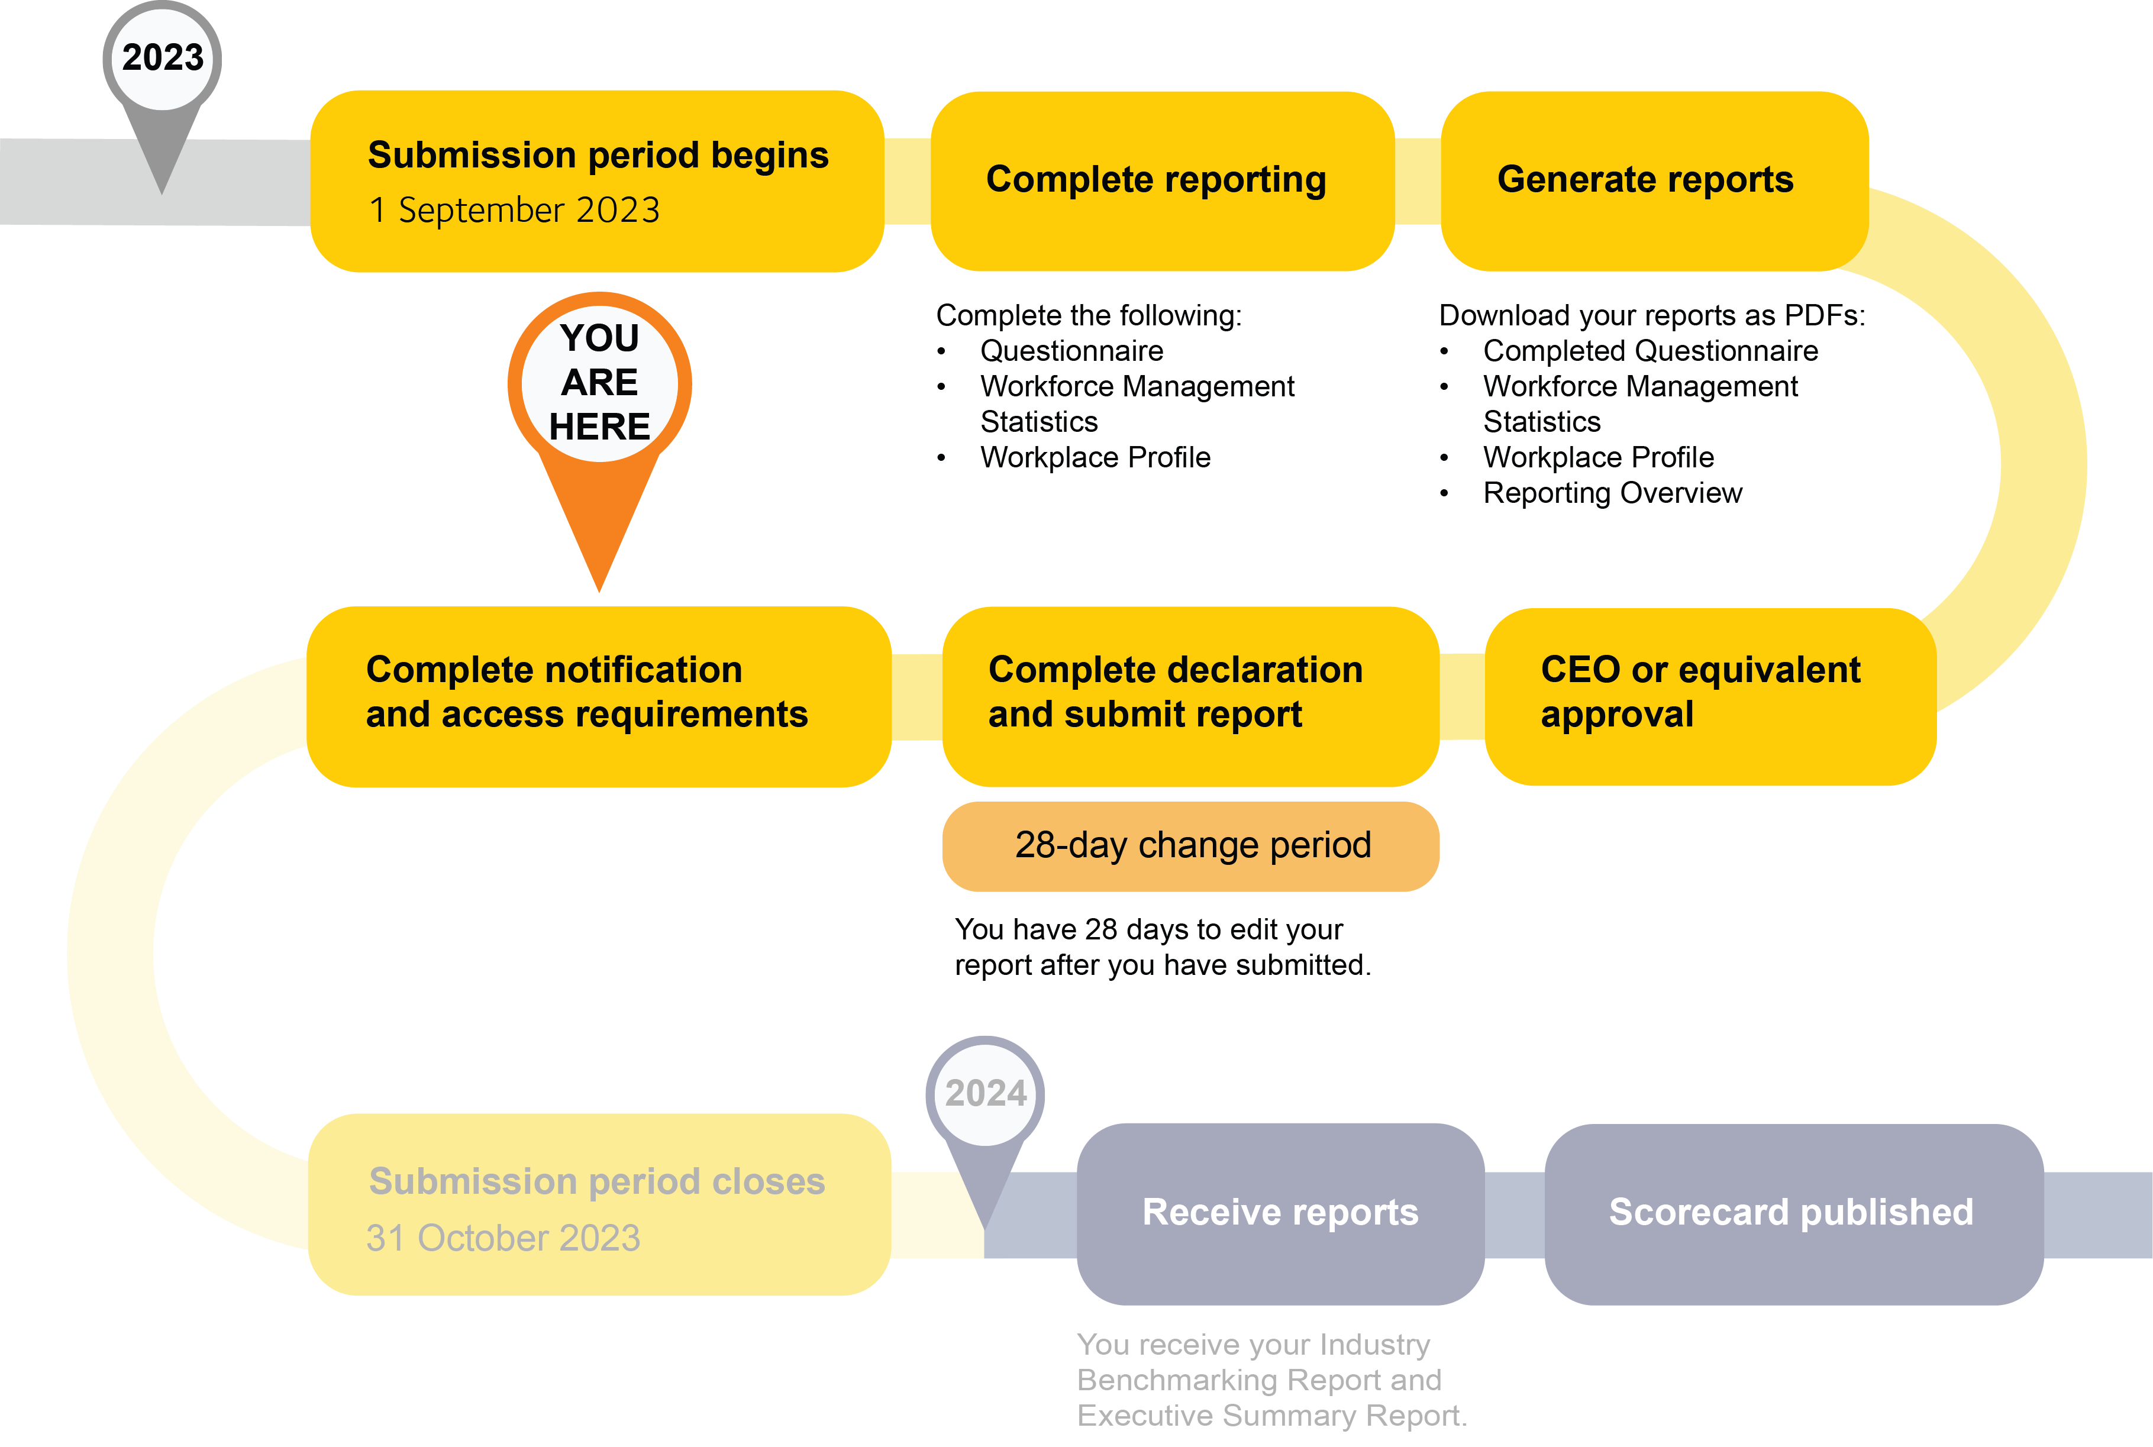

Checklist
Use the checklist below to help you to complete your notification and access requirements. Note that some items must be completed within specific time frames.

 | Action | Date required
- Retrieve your reports
☐ | Retrieve the following reports once you have completed your gender equality reporting.  Public reports (public data):  - Questionnaire – Public Report  - Workforce Management Statistics – Public Report  - Workplace Profile – Public Report  Confidential reports (not publicly shared):  - Questionnaire – Confidential  - Workplace Profile – Confidential  - Reporting Overview  The documents will generate in the Data and Insights tab of the portal under Reports after approximately 5-25 minutes (longer during peak periods). The public reports (which contain your public data) are what you must share with employees and members or shareholders. | Once you have completed your Questionnaire, Workforce Management Statistics, and Workplace Profile
- Notify the employee organisations with members in your workplace
☐ | Notify employee organisations (e.g., unions) with members in its workplace that you have submitted a gender equality report to WGEA. This can be done via email or another communication method you see fit. | Within 7 days of submitting your gender equality report
☐ | Inform employee organisations with members in your workplace they can comment on the public reports. You must also tell the organisations that comments on the reports may be given to the employer or WGEA. See more under “Comments on your public reports” below.

- Notify your employees
☐ | Notify your employees that you have submitted a gender equality report to WGEA and advise employees on how to access the public reports.  This can be done through your normal means of communication to employees, such as newsletters, workplace meetings, or other existing communication methods. | As soon as reasonably practicable after submitting report
☐ | Give employees access to the public reports. This can be done through attaching to an email, hosting on your intranet, or providing a link on your website.  Note that in your submission for the following year, you will be asked to report the date for which you shared this year’s public reports with employees.
☐ | Notify employees that they have an opportunity to comment on the public reports. You must also tell your employees that comments on the public reports may be given to the employer or WGEA. See more under “Comments on your public reports” below.
- Notify your members / shareholders
☐ | Notify members that you that you have submitted a gender equality report to WGEA and advise members on how to access the public reports. | As soon as reasonably practicable after submitting report
☐ | Give members access to the public reports. This can be done through attaching the reports an email, hosting them on your website, or even providing a hard copy.

Actions Comparison Chart
Action | Employee Organisations  Within 7 days of lodging the report | Employees  As soon as reasonably practicable after submission | Members / Shareholders  As soon as reasonably practicable after submission
Notify that you have submitted to WGEA
Give access to public reports
Inform of opportunity to comment

Comments on your public reports
There is no time restriction on when comments on the gender equality report submission can be provided. It is recommended that comments are captured within the 28-day change period after employers submit their report as edits can still be made within this period where required. Your organisation may choose to respond to the comments separately.

Suggested wording for notification and access communication
The following templates can be used as a guide to assist you with the requirements. You may wish to use alternate wording, as long as the requirements of the Act are satisfied.

For employee organisations with members in your workplace
In accordance with the requirements of the Workplace Gender Equality Act 2012 (Act), I am writing to inform you that, on [insert date], [insert name of employer] lodged its annual public report with the Workplace Gender Equality Agency (WGEA).
As an employee organisation with members in this workplace, the Act provides for your organisation to comment on the report either to us by [insert method for commenting to the employer] or to WGEA. Please refer to WGEA’s guidelines on this process on their website.

For employees
In accordance with the requirements of the Workplace Gender Equality Act 2012 (Act), I am writing to inform you that, on [insert date], [insert name of employer] lodged its annual public report with the Workplace Gender Equality Agency (WGEA).
[Insert how you are providing access to the public data, e.g.: “To access a copy of the public data reports, please click on the link attached to this email” or “A copy of this report is available on our intranet” or “A copy of this public data is attached to this email.”]
As employees of this organisation, you may make comments on the report to us by [insert how to comment to the employer] or to WGEA. Please refer to WGEA’s guidelines on this process on their website.

For members / shareholders
In accordance with the requirements of the Workplace Gender Equality Act 2012 (Act), I am writing to inform you that, on [insert date], [insert name of employer] lodged its annual public report with the Workplace Gender Equality Agency (WGEA).
[Insert how you are providing access to the public data, e.g.: “To access a copy of the public data reports, please click on the link attached to this email” or “A copy of this report is available on our intranet” or “A copy of this public data is attached to this email.”]

If you are an APS agency that has opted for the APSC to bulk upload your employee data, you will not need to complete a workplace profile.

