2018-19 Indicative format:
Workplace profile and reporting questionnaire
Reporting under the Workplace Gender
Equality Act 2012

Version 3.0

Changes to the indicative format
Change made | Page/Section/Question
Removed wording ‘in 2018” to “Relevant employers can get ready for reporting as follows:” | 3
Changed date from 206-2017 to 2016-2017 | 4

Section 1: Overview
Under the Workplace Gender Equality Act 2012 (Act) relevant employers are required to complete and submit a report covering standardised reporting matters under six gender equality indicators (GEIs). The format of this report includes a workplace profile and a reporting questionnaire.
- Workplace profile: The workplace profile reflects data required under gender equality indicators one (GEI 1: gender composition of the workforce) and three (GEI 3: equal remuneration between women and men) and is in an Excel format.
- Reporting questionnaire: The reporting questionnaire reflects data required under all six gender equality indicators and includes 17 questions. Response options in the reporting questionnaire are typically a yes/no or table format. Where ‘no’ is selected, employers have the option to provide a reason for this by either selecting from a series of provided options or via a free-text box.

About this document
Relevant employers are required to complete and submit their report online using the Workplace Gender Equality Agency’s (Agency) secure online portal. To assist relevant employers to prepare for reporting in 2019, this document provides the indicative format of the:
- workplace profile in Section 2
- reporting questionnaire in Section 3.
Relevant employers can get ready for reporting as follows:
- workplace profile – start preparing data by using excel worksheeets provided by the Agency. (Remember, when you actually start reporting online, you will have to download the system generated template from the reporting portal, then populate, upload and submit that document, not the worksheets.)
- reporting questionnaire – relevant employers can start planning their responses and gathering data for the questions set out in the reporting questionnaire. Note that the questionnaire format in Section 3 of this document is indicative only. It is not the reporting template.

Overview of reporting under the Act
For information on the Agency and reporting under the Act please refer to the Quick guide to reporting and compliance located on the Agency’s website at www.wgea.gov.au .

Minimum standards
Minimum standards relate to specified gender equality indicators (GEIs) and are set by the Minister in the Workplace Gender Equality (Minimum Standards) Instrument 2014.
Minimum standards represent the standard needed to achieve a particular objective under a GEI. To meet the minimum standard, relevant employers with 500 or more employees (in total within the corporate structure) must have a policy or strategy in place that specifically supports gender equality in relation to one, or more, of the following GEIs. The related questions in the reporting questionnaire are also detailed below.

- GEI 1: gender composition of the workforce:
‘Yes’ to having a policy or strategy for any of the options 1.1 to 1.9
OR
- GEI 3: equal remuneration between women and men:
‘Yes’ to having a policy or strategy for question 3 and yes to 3.1.
OR
- GEI 4: availability and utility of employment terms, conditions and practices relating to flexible working arrangements for employees and to working arrangements supporting employees with family or caring responsibilities:
‘Yes’ to having a policy or strategy for question 10.
OR
- GEI 6: any other matters specified by the Minister in a legislative instrument: sex-based harassment and discrimination:
‘Yes’ to having a policy or strategy for question 16.
If an employer that is required to meet a minimum standard does not do so, it will have a further two reporting periods to improve against the minimum standard before it may be deemed non-compliant by the Agency.
For example, for employers who reported in 2016-17 and 2017-18 that they did not have a formal policy or strategy in place in one of the above GEIs, and report in 2018-19 that one has still not been put in place, they may be non-compliant with the Act.
For more details on meeting minimum standards, refer to resources provided in the ‘Minimum standards’ section of the website.

Competitor Analysis Benchmark Reports and data quality
Standardised reporting under the Act enables the Agency to provide relevant employers with customised confidential Competitor Analysis Benchmark Reports as well as aggregated national public industry benchmark data.
Critical to the provision of quality Competitor Analysis Benchmark Reports (CABRs) is the reliability of data provided by employers through the reporting process. To ensure the CABRs are meaningful and comparable over time it is essential that employers take care to accurately:
- classify their employees to manager and non-manager categories
- calculate remuneration data as indicated in the workplace profile (for corporate structures, this must be done in relation to each employing entity in the group – refer to the Guide:Entity level reporting for corporate structures & requirements for combined reports.
- ensure responses in the reporting questionnaire reflect shared industry interpretations of key concepts and terms within your industry.
Note that the online system will perform a validation of the data and inform you of possible data entry errors, or possible data quality errors.

Reference guide
This Indicative format is a companion document to the Reference guide, available on the Agency’s website. The Reference guide provides employers with detailed information required for reporting, including key terms and definitions and guidance for engaging with key stakeholders within their organisation.

Confidentiality
Information relating to remuneration included in a report will not be published by the Agency unless written permission from the relevant employer has been provided. Remuneration data may be published in an aggregated form so long as it does not disclose information about a specific employer or person. This will enable the Agency to collect and analyse data and to develop other resources on pay equity to benefit employers. Please refer to the WGEA protocol on sharing reporting data section on our website.

Section 2: Workplace profile
Relevant employers are required to complete a workplace profile. The workplace profile reflects data required under GEI 1 (gender composition of the workforce) and GEI 3 (equal remuneration between women and men).
A workplace profile must include:
- actual headcount (that is, the actual number of employees, not full-time equivalents) of all employees (including full-time, part-time, individuals on a fixed-term contract and casuals)
- data which reflects your workforce at a point in time within the 2018-19 reporting period (1 April 2018 to 31 March 2019). You may choose to use data based on the financial year that concludes during the reporting period. For example, you may choose to use data as at 30 June 2018.
The following information needs to be provided in the workplace profile which is in an Excel format:
- WGEA-defined standardised occupational categories for managers and non-managers
- for managers only: reporting level from the CEO/head of business (or equivalent)
- gender
- graduate/apprentice
- employment status:
  - full-time permanent/ongoing
  - full-time contract (fixed-term)
  - part-time permanent/ongoing
  - part-time contract (fixed-term)
  - casual.
- remuneration:
  - annualised, full-time equivalent base salary and,
  - annualised, full-time equivalent total remuneration.

Selecting unit level or aggregated data
The workplace profile may be provided to the Agency as either unit level data or aggregated data. Table 1 below provides a summary of the differences between the two options. Remember, you only have to choose ONE of these options. If you use the unit level data template, the system will automatically generate aggregated tables for you to review.
For both options, we recommend you prepare your data offline by populating the 2019 workplace profile worksheets available from the website. This allows you to sort, find or replace data if needed. The system-generated workplace profile template via the online portal is encrypted and does not allow you to sort, find or replace data. Data from your worksheets can be copied and pasted into the system-generated template.

Table 1: Differences between unit level data and aggregated data
Option 1: Unit level data | Option 2: Aggregated data
Simplest option, one table to complete.  One employee per line (de-identified employee data). | Two tables to complete: one for managers, one for non-managers*.  *This is because the reporting level to the CEO/head of business is only required for managers. Graduate and apprentice categories only apply to non-managers.
Once uploaded, the online system generates the aggregated tables from your unit level data and automatically calculates the relevant remuneration totals. | Employers need to calculate:  - aggregated employee numbers per category  - aggregated AVERAGE base salary and total remuneration per category.
Important note: the public report only displays the workplace profile as aggregated tables, and does not contain remuneration data.

Option 1: 2018-2019 unit level data template
Table 2 shows the layout of the Excel table if an employer decides to provide unit level data. Each line in the table represents one employee. Employee names and identification numbers are not required in the Excel template you submit online. If they are included, they will not be published in your public and confidential reports. However, you may wish to include them in your own worksheets.
When completing your workplace profile, ensure you are following the data entry requirements provided in the column headings. The columns are numbered to reflect the columns referred to in validation error reports downloaded online during the workplace profile upload process.
Table 2: Unit level data template

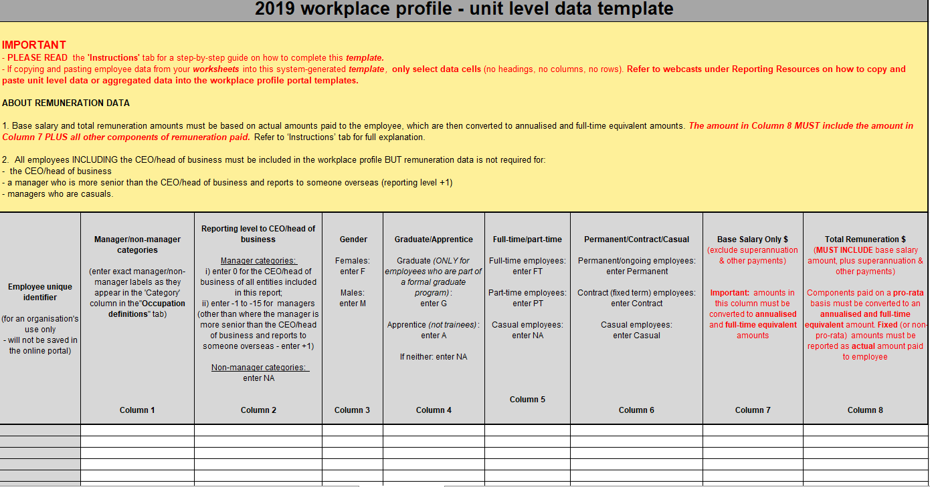

Option 2: 2018-2019 aggregated data template
If an employer decides to provide workplace profile data at an aggregated level, two tables will need to be completed:
- one for managers (refer layout in Table 3)
- one for non-managers (refer layout in Table 4).
For each category, remuneration data MUST be averaged for each category (i.e. NOT the total amount for each category).
Please note that based on the information you provide, the aggregated template for managers is customised by the system for your organisation and will therefore include the provided number of ‘Reporting levels to the CEO’ for each manager category. The following tables are examples only.
The subtotal and overall total of employees will auto-calculate.
The columns are numbered to reflect the columns referred to in validation error reports downloaded online during the workplace profile upload process.
Table 3: All managers – aggregated data template

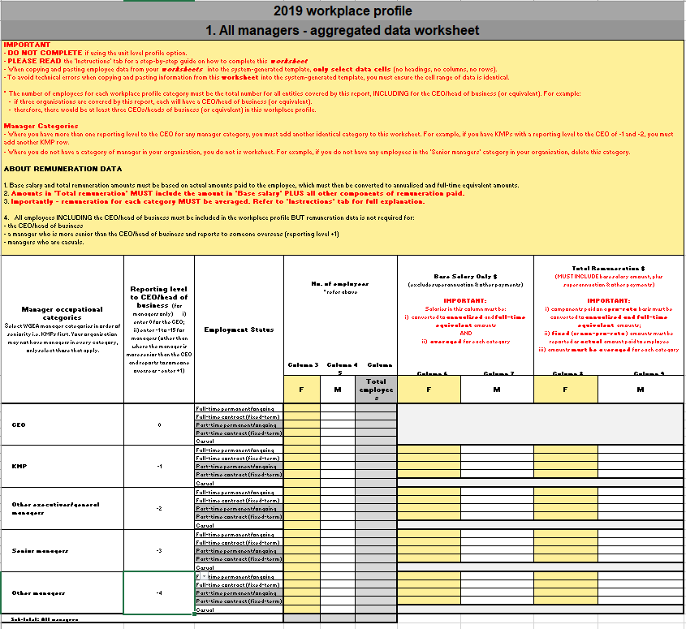
Table 4: All non-managers – aggregated data template
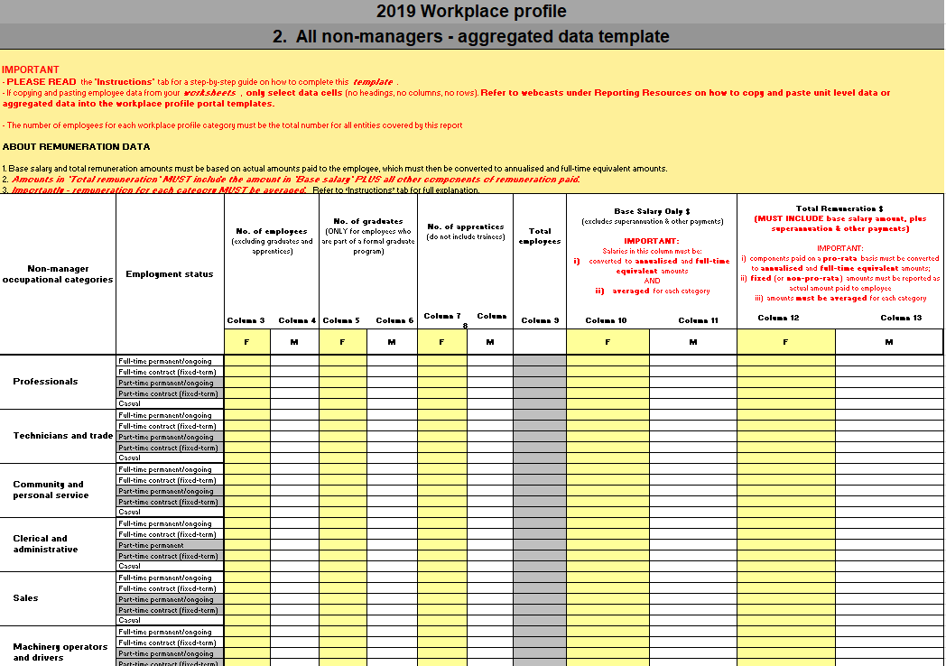

Standardised occupational categories of managers and non-managers
To enable comparability, including for the Competitor Analysis Benchmark Reports, employers are required to classify and report on their workforce against WGEA-defined standardised occupational categories as outlined in the Workplace Gender Equality (Matters in relation to Gender Equality Indicators) Instrument 2013 (No.1). The non-manager categories mirror the major groups in the classification structure the Australian and New Zealand Standard Classification of Occupations (ANZSCO) managed by the Australian Bureau of Statistics (refer Table 6 below).

Standardised occupational categories of managers
Managers are categorised as below and defined in Table 5:
IMPORTANT: When allocating employees to an occupational category, use the definition for each category as outlined in Tables 5 and 6 rather than referring to job titles.

- CEO/head of business (or equivalent)
- KMP (key management personnel)
- other executives/general managers
- senior managers
- other managers.
Table 5: Workplace profile: standardised occupational categories of managers
Please note: a manager does not need to be responsible for people to be defined as a manager. Also note that a supervisor is not a manager. As such, employees in this category within your organisation need to be classified according to one of the eight standardised non-manager categories provided in Table 6.
Managers | Definition
CEO  (Chief executive officer or equivalent) | - The CEO/head of business (or equivalent) refers to the head of business in Australia, and is reported on separately to other key management personnel. For corporate structures with one or more relevant subsidiaries, the definition of CEO includes the head of business for each relevant subsidiary in Australia.
KMP  (Key management  personnel) | - ‘Key management personnel’ (KMP) refers to those persons who have authority and responsibility for planning, directing and controlling the activities of the entity, directly or indirectly, including any director (whether executive or otherwise) of that entity, in accordance with Australian Accounting Standards Board AASB124.  - A defining feature of KMPs is that their influence is at the entity level. They are likely to be functional heads such as head of operations or head of finance and direct how that component contributes to the entity’s outcome, with a strategic focus.  - The KMP is a manager who represents at least one of the major functions of the organisation and participates in organisation-wide decisions with the CEO.
Other executives/general managers | - ‘Other executives/general managers’ hold primary responsibility for the equivalent of a department or a business unit. In a large organisation, this manager might not participate in organisation-wide decisions with the CEO.  - Alternatively, this manager could have influence in organisation-wide decision making forums to provide expertise or project development but because they do not actually hold authority at an entity level they would not be defined as a KMP.
Senior managers | - ‘Senior managers’ are charged with one or more defined functions, departments or outcomes. They are more likely to be involved in a balance of strategic and operational aspects of management. Some decision-making at this level would require approval from one of the three management levels above it.  - ‘Senior managers’ are responsible for resourcing, a budget and assets (capital expenditure).
Other managers | - ‘Other managers’ plan, organise, direct, control and coordinate an operational function. They usually oversee day to day operations, working within and enforcing defined company parameters.  - They might implement, determine, monitor and review strategies, policies and plans to meet business needs as it relates to their own function/work area.  - An ‘other manager’ is accountable for a defined business outcome which usually involves the management of resources and includes time management, coordination of different functions or people, financial resources, and other assets (for example facilities or IT infrastructure).  - Line managers would be included in this category, however supervisors would not be included.

Standardised occupational categories of non-managers
Employees that are non-managers are classified against the following standardised occupational categories, as defined in Table 6 below:
- professionals
- technicians and trade
- community and personal service
- clerical and administrative
- sales
- machinery operators and drivers
- labourers
- other.
In addition, where the following two categories apply to an employee in a non-manager category, this needs to be reflected in your workplace profile:
- graduates
- apprentices.
Table 6: Workplace profile: standardised occupational categories for non-managers
Occupational categories  of non-managers | Definition
Professionals | Perform analytical, conceptual and creative tasks through the application of theoretical knowledge and experience in the fields of the arts, media, business, design, engineering, the physical and life sciences, transport, education, health, information and communication technology, the law, social sciences and social welfare.
Technicians and trade | Perform a variety of skilled tasks, applying broad or in-depth technical, trade or industry-specific knowledge, often in support of scientific, engineering, building and manufacturing activities.
Community and personal service | Provide services in hospitality, policing and emergency services, security, travel and tourism, fitness, sports and personal services. It includes carers and aides in schools and community settings as well as those who assist health professionals in the provision of patient care, and those who provide information and support on a range of social welfare matters, and in the areas of aged care and childcare.
Clerical and administrative | Provide support to managers, professionals and organisations by organising, storing, manipulating and retrieving information.
Sales | Sell goods, services and property, and provide sales support in areas such as operating cash registers and displaying and demonstrating goods.
Machinery operators and drivers | Operate machines, plant, vehicles and other equipment to perform a range of agricultural, manufacturing and construction functions and move materials.
Labourers | Perform a variety of routine and repetitive physical tasks using hand tools, power tools, and machines either as an individual or as part of a team assisting more skilled workers such as trades workers, and machinery operators and drivers.
Other | Employees whose work is highly specialised or unique and is not defined by above categories. Please refer to the Guide: non-manager categories document at www.wgea.gov.au for more detailed examples of roles under each non-manager category.
Refer to the Guide: non-manager categories for examples of roles in your industry that fit under each of these non-manager categories.
In addition, where the following two categories apply to an employee in a non-manager category, this needs to be reflected in your workplace profile:
- graduate: any person employed in a formal graduate program. Someone who has graduated from a tertiary institution but is NOT part of a formal graduate program, is not to be included in this category. Graduates employed in a formal graduate program need to be classified according to one of the eight standardised occupational categories of non-managers provided.
- apprentice: any person employed by an employer as an apprentice. A trainee is not considered an apprentice. Trainees need to be classified according to one of the eight standardised occupational categories of non-managers provided.

Reporting level to CEO/head of business (or equivalent) – for managers only
Reporting levels to the CEO/head of business are only required for managers, they are not required for non-managers. For corporate structures, this needs to be done in relation to the CEO/head of business of the entity where the manager works (refer to the Guide: Entity level reporting for Corporate structures & requirements for combined reports).
Once managers have been classified in the applicable standardised manager occupational category, relevant employers then need to allocate the appropriate reporting level to the CEO (or equivalent).
The reporting level to the CEO is the relative hierarchical position of the manager based on the internal organisational chart (i.e. the number of levels, or distance, between the manager and the CEO).
The reporting level to the CEO is to be reported as follows:
- The CEO’s reporting level to the CEO is recorded as ‘0’.
- The sequence of reporting levels in relation to the CEO cascades from -1 to -2, -3 etc. and can range from -1 to -15 (below CEO). For example, managers who report to the CEO have a reporting level of ‘-1’.
- Where there is no CEO in Australia and the most senior manager reports directly to someone based overseas, the reporting level to the CEO for that individual would still be recorded as ‘-1’. This is because, in Australia, they are the first level of seniority.
- For a manager who is more senior than the CEO and who reports to someone overseas (this typically occurs in global organisations) the reporting level to the CEO is recorded as ‘+1’ (above CEO).
- There may be more than one reporting level to the CEO within any of the standardised manager categories.
- For corporate structures: refer to where a manager reports to someone in another organisation in the group, their ‘reporting level to the CEO’ needs to be based on their level of seniority in the hierarchy of the organisation where they work (refer to the Guide: Entity level reporting for Corporate structures & requirements for combined reports). It reflects the relative distance between them and the CEO/head of business of the entity where they work. (This is usually reflected in that entity’s organisation chart.)
There may be more than one reporting level to the CEO within any of the standardised management categories.

Remuneration
Relevant employers must provide the remuneration data for all employees excluding:
- the CEO/head of business (or equivalent)
- managers with a reporting level to the CEO of +1 (i.e. those who are more senior than the CEO and report to someone overseas [typically global entities])
- those managers who are employed on a casual basis.
The elements of remuneration required to be reported on in the workplace profile are:
- Annualised, full-time equivalent base salary: base salary refers to gross (pre-tax) salary paid to employees, including salary sacrificed items, but excluding allowances, superannuation and any other additional payments.
- Annualised, full-time equivalent total remuneration: total remuneration includes base salary plus any additional benefits whether payable directly or indirectly, whether in cash or in a form other than cash. It includes bonus payments (including performance pay), superannuation, discretionary pay, other allowances and other (for example share allocations). Important notes for the calculation of the components of total remuneration:
    - Components of total remuneration paid on a pro-rata basis (e.g. bonuses that are paid on a pro-rata basis for employees who have not been employed for 12 months or have worked part-time) MUST BE annualised, and converted to full-time equivalent amounts.
    - Components of total remuneration paid as fixed amounts or on a non-pro-rata basis, must be reported as actual amounts paid to the employee (that is, DO NOT annualise or convert to a full-time equivalent amount). For example, fixed rate bonuses, shares, overtime and allowances where employees are paid the same amount regardless of whether they have been employed for less than 12 months or whether they are employed on a full-time or part-time basis
IMPORTANT:
- if someone is employed for only part of the year their salary data needs to be calculated as if they had worked for the full year (i.e. “annualised”)
- if someone is employed on a part-time or casual basis their salary data needs to be calculated as if they had worked full-time for the full year (i.e. “full-time equivalent”).
To calculate annualised and full-time equivalent base salary and total remuneration amounts, you must use what an employee has actually earnt in the 12 months prior to your point-in-time date for your workplace profile as the basis for the calculation, not their contractual amount.

Section 3: Reporting questionnaire
Employers are also required to complete the reporting questionnaire. The reporting questions are set out on the following pages. Compliance reports are to be completed and submitted through the secure online portal. As such, the questionnaire format in this document is indicative only, it IS NOT the reporting template.

Overview of the reporting questionnaire
For the 2018-19 reporting period, the reporting questionnaire includes 17 questions that reflect standardised reporting matters under the six GEIs. There are no changes to reporting requirements in 2018-19. However minor improvements have been made to the format of the questionnaire, simplifying wording and layout.

Responses and free-text boxes
Response options in the questionnaire are typically a yes/no or table format. Where ‘no’ is selected, employers have the option to provide a reason for this either using pre-set options or a free-text box.
When providing details in free-text boxes throughout the reporting questionnaire please do so in accordance with the Privacy Act 1988 and ensure no confidential information or personal information (such as any information that would personally identify an employee) is included as it will be included in your public report on the Agency’s website.

GEI 1: Gender composition of the workforce
 | Question 1 (1.1-1.9) is one of the four options of a policy or strategy that employers must have in place to meet the minimum standard. Refer to the minimum standards section on the Agency’s website for more details.
1. | Do you have formal policies and/or formal strategies in place that SPECIFICALLY SUPPORT GENDER EQUALITY relating to the following :  - Policy or strategy may be standalone, AND/OR contained within another policy/strategy.  - Policies are the guidelines, rules and procedures developed by an organisation to govern its actions (often in recurring situations). They define the limits (do’s and don’ts) within which decision must be made.  - A strategy is a plan of action designed to achieve one or more of the organisation’s objectives. Strategy fills the gap between “where we are” and “where we want to be”, that is, “how are we going to get there”?
1.1 | Recruitment? | ☐ Yes ☐ No
1.2 | Retention? | ☐ Yes ☐ No
1.3 | Performance management processes? | ☐ Yes ☐ No
1.4 | Promotions? | ☐ Yes ☐ No
1.5 | Talent identification/identification of high potentials? | ☐ Yes ☐ No
1.6 | Succession planning? | ☐ Yes ☐ No
1.7 | Training and development? | ☐ Yes ☐ No
1.8 | Key performance indicators for managers relating to gender equality? | ☐ Yes ☐ No
1.9 | Gender equality overall? | ☐ Yes ☐ No
In completing options 1.1 to 1.9:
For those who select yes, you can select policy and/or strategy options:
☐ Policy
☐ Strategy
For those that select no, you will be provided with the option of selecting the applicable reasons which include:
☐ No (you may specify why no formal policy or formal strategy is in place)
☐ No, currently under development, please enter date this is to be completed: ___
☐ Insufficient resources/expertise
☐ Not a priority

1.10 | How many employees were promoted during the reporting period against each category below? IMPORTANT: Because promotions are included in the number of appointments in Q1.11, the number of promotions should never exceed appointments.  - This is the total number of promotions made during the reporting period.  - Promotion means where a person has advanced or been raised to a higher office or rank on an ongoing basis.  - Temporary higher duties are NOT considered a promotion. Typically, this does not include movement within a salary band unless it is a move to a higher office or rank.  - No cell should be left blank, please enter “0” (zero) where there is no data.  Managers Non-managers  Female Male Female Male  Permanent/ongoing full-time employees  Permanent/ongoing part-time employees  Fixed-term contract full-time employees  Fixed-term contract part-time employees  Casual employees
1.11 | How many appointments in total (including the number of promotions above in Q1.10) were made to manager and non-manager roles during the reporting period (based on WGEA-defined managers/non-managers)? IMPORTANT: promotions need to be added to these totals because they are considered internal appointments.  - This is the total number of appointments, internal and external, made in the reporting period.  - All appointments need to be included regardless of how they were made, e.g. through recruitment excercises, cold canvassing, previously-submitted resumes.No cell should be left blank, please enter “0” (zero) where there is no data.  Female Male  Number of appointments made to MANAGER roles (including promotions)  Number of appointments made to NON-MANAGER roles (including promotions)
1.12 | How many employees resigned during the reporting period against each category below?  - This is the total number of resignations made during the reporting period. Resigned refers to employees who have given up their employment voluntarily, NOT those who are subject to redundancies or employer-initiated terminations.  - No cell should be left blank, please enter “0” (zero) where there is no data.  Managers Non-managers  Female Male Female Male  Permanent/ongoing full-time employees  Permanent/ongoing part-time employees  Fixed-term contract full-time employees  Fixed-term contract part-time employees  Casual employees
1.13 | If your organisation would like to provide additional information relating to gender equality indicator 1, please do so below.  Free-text box  - This question is optional.

GEI 2: Gender composition of governing bodies
2. | The organisation(s) you are reporting on will have a governing body. In the Act, governing body is defined as “the board of directors, trustees, committee of management, council or other governing authority of the employer”. This question relates to the highest governing body for your Australian entity, even if it is located overseas.  - For private or publicly listed companies, you will have one or more directors or a board of directors  - For trusts, the trustee is the governing body/board  - For partnerships, the governing body/board is likely to comprise all or some (if elected) partners  - For organisations whose governing body is the same as their parent entity’s governing body/board, it is still deemed to have a governing body  - For religious structures, you may have a canonical advisor, bishop or archbishop  - For other structures that do not fall into any of the above categories, your committee of management would be considered your governing body/board.
2.1 | Please answer the following questions relating to each governing body covered in this report.  Note: If this report covers more than one organisation, the questions below will be repeated for each organisation before proceeding to question 2.2.  If your organisation’s governing body is the same as your parent entity’s, you will need to add your organisation’s name BUT the numerical details of your parent entity’s governing body.  You only need to report on the governing bodies of organisations in your corporate structure that have 80 or more employees (unless you are the parent organisation).
2.1a | Organisation name?  Free text box
2.1b | How many Chairs on this governing body?  Female Male  Number
2.1c | How many other members are on this governing body (excluding the Chair/s)?  Female Male  Number
2.1d | Has a target been set to increase the representation of women on this governing body?  ☐ Yes  ☐ No (you may specify why a target has not been set)  ☐ Governing body has gender balance (i.e. 40% women/40% men/20% either)  ☐ Currently under development, please enter date this is due to be completed: ___  ☐ Insufficient resources/expertise  ☐ Do not have control over governing body appointments (provide details why): ___  ☐ Not a priority  ☐ Other (provide details): ___
2.1e | What is the percentage (%) target?  Free text box
2.1f | What year is the target to be reached?  Free text box
2.1g | Are you reporting on any other organisations in this report?  ☐ Yes  ☐ No
2.2 | Do you have a formal selection policy and/or formal selection strategy for governing body members for ALL organisations covered in this report?  - Policy or strategy may be standalone, AND/OR contained within another policy/strategy.
☐ Yes (select all applicable answers)
☐ Policy
☐ Strategy
☐ No (you may specify why no selection policy or formal selection strategy is in place)
☐ In place for some governing bodies
☐ Currently under development, please enter date this is due to be completed: ___
☐ Insufficient human resources/expertise
☐ Do not have control over governing body appointments (provide details why): ___
☐ Not a priority
☐ Other (provide details): ___

2.3 | Does your organisation operate as a partnership structure (i.e. select NO if your organisation is an “incorporated” entity – Pty Ltd, Ltd or Inc; or an “unincorporated” entity)?  ☐ Yes  ☐ No
2.4 | Enter the number of EQUITY and NON-EQUITY partners (excluding managing partner) against the WGEA standardised manager and non-manager categories below.  - Only those engaged under partnership terms and conditions should be included in this table.  - Non-equity partners may also be referred to as fixed profit share or fixed-draw partners.  - Where the person holds the title of Partner but is engaged on an employment contract they should be reported on in the workplace profile.  - The managing partner should be reported on separately in the CEO row of your workplace profile.  - The composition of your governing body also needs to be entered in question 2. This may include all or some of your equity partners below.  - No cell should be left blank, please enter “0” (zero) where there is no data.
Based on WGEA-defined manager categories
EQUITY and NON-EQUITY PARTNERS ONLY
 | Full-time EQUITY and NON-EQUITY partners |  | Part-time EQUITY and NON-EQUITY partners
 | Females | Males | Females | Males
Key management personnel (KMPs) (excluding managing partner)
Other executives/general managers
Senior managers
Other managers
Non-managers

2.5 | If your organisation would like to provide additional information relating to gender equality indicator 2, please do so below.  Free text box.  - This question is optional.

GEI 3: Equal remuneration between women and men
Questions 3 and 3.1 combined is one of the four options of a policy or strategy that employers must have in place to meet the minimum standard. Refer to the minimum standards section on the website.

3 | Do you have a formal policy and/or formal strategy on remuneration generally?  - Policy or strategy may be standalone, AND/OR contained within another policy/strategy.  ☐ Yes (select all applicable answers)  ☐ Policy  ☐ Strategy  ☐ No (you may specify why no formal policy or formal strategy is in place)  ☐ Currently under development, please enter date this is due to be completed: ___  ☐ Insufficient resources/expertise  ☐ Salaries set by awards/industrial or workplace agreements  ☐ Non-award employees paid market rate  ☐ Not a priority  ☐ Other (provide details): ___
3.1 | Are specific gender pay equity objectives included in your formal policy and/or formal strategy?  ☐ Yes (provide details in questions 3.2)  ☐ No (you may specify why pay equity objectives are not included in your formal policy or formal  strategy)  ☐ Currently under development, please enter date this is due to be completed: ___  ☐ Salaries set by awards/industrial or workplace agreements  ☐ Insufficient resources/expertise  ☐ Non-award employees paid market rate  ☐ Not a priority  ☐ Other (provide details): ___
3.2 | Does your formal policy and/or formal strategy include any of the following gender pay equity objectives (select all applicable answers)?  ☐ To achieve gender pay equity  ☐ To ensure no gender bias occurs at any point in the remuneration review process (for example at commencement, at annual salary reviews, out-of-cycle pay reviews, and performance pay reviews)  ☐ Be transparent about pay scales and/or salary bands  ☐ To ensure managers are held accountable for pay equity outcomes  ☐ To implement and/or maintain a transparent and rigorous performance assessment process  ☐ Other (provide details): ___
4. | Have you analysed your payroll to determine if there are any remuneration gaps between women and men (i.e. conducted a gender pay gap analysis)?  ☐ Yes – the most recent gender remuneration gap analysis was undertaken:  ☐ Within last 12 months  ☐ Within last 1-2 years  ☐ More than 2 years ago but less than 4 years ago  ☐ Other (provide details): ___  ☐ No (you may specify why you have not analysed your payroll for gender remuneration gaps)  ☐ Currently under development, please enter date this is due to be completed: ___  ☐ Insufficient resources/expertise  ☐ Salaries for ALL employees (including managers) are set by awards or industrial agreements, AND there is no room for discretion in pay changes (for example because pay increases occur only when there is a change in tenure or qualifications)  ☐ Salaries for SOME or ALL employees (including managers) are set by awards or industrial agreements and there IS room for discretion in pay changes (because pay increases can occur with some discretion such as performance assessments)  ☐ Non-award employees are paid market rate  ☐ Not a priority  ☐ Other (provide details): ___
4.01 | You may provide details on the type of gender remuneration gap analysis that has been undertaken (for example like-for-like and/or organisation-wide).  Free-text box  - A like-for-like gap compares the same or similar roles. An organisation-wide gap is the difference between the average remuneration of all women and the average remuneration of all men in your organisation.
4.1 | Did you take any actions as a result of your gender remuneration gap analysis?  ☐ Yes – indicate what actions were taken (select all applicable answers)  ☐ Created a pay equity strategy or action plan  ☐ Identified cause/s of the gaps  ☐ Reviewed remuneration decision-making processes  ☐ Analysed commencement salaries by gender to ensure there are no pay gaps  ☐ Analysed performance ratings to ensure there is no gender bias (including unconscious bias)  ☐ Analysed performance pay to ensure there is no gender bias (including unconscious bias)  ☐ Trained people-managers in addressing gender bias (including unconscious bias)  ☐ Set targets to reduce any like-for-like gaps  ☐ Set targets to reduce any organisation-wide gaps  ☐ Reported pay equity metrics (including gender pay gaps) to the governing body/board  ☐ Reported pay equity metrics (including gender pay gaps) to the executive  ☐ Reported pay equity metrics (including gender pay gaps) to all employees  ☐ Reported pay equity metrics (including gender pay gaps) externally  ☐ Corrected like-for-like gaps  ☐ Conducted a gender-based job evaluation process  ☐ Implemented other changes (provide details): ___  ☐ No (you may specify why no actions were taken resulting from your remuneration gap analysis)  ☐ No unexplainable or unjustifiable gaps identified  ☐ Currently under development, please enter date this is due to be completed: ___  ☐ Insufficient resources/expertise  ☐ Salaries set by awards/industrial or workplace agreements  ☐ Non-award employees are paid market rate  ☐ Unable to address cause/s of gaps (provide details why): ___  ☐ Not a priority  ☐ Other (provide details): ___
4.2 | If your organisation would like to provide additional information relating to gender equality indicator 3, please do so below:  Free-text box.  - This question is optional.

GEI 4: Availability and utility of employment terms, conditions and practices relating to flexible working arrangements for employees and to working arrangements supporting employees with family or caring responsibilities
5. | “PRIMARY CARER” is the member of a couple or a single carer, REGARDLESS OF GENDER, identified as having greater responsibility for the day-to-day care of a child.  Do you provide EMPLOYER FUNDED paid parental leave for PRIMARY CARERS that is available for women AND men, in addition to any government funded parental leave scheme for primary carers?
☒ Yes. (Please indicate how employer funded paid parental leave is provided to the primary carer):
☐ By paying the gap between the employee’s salary and the government’s paid parental leave scheme
☐ By paying the employee’s full salary (in addition to the government’s paid scheme), regardless of the period of time over which it is paid. For example, full pay for 12 weeks or half pay for 24 weeks
☐ As a lump sum payment (paid pre- or post- parental leave, or a combination)
☐ No, we offer paid parental leave for primary carers that is available to women ONLY (e.g. maternity
leave). (Please indicate how employer funded paid parental leave is provided to women ONLY):
☐ By paying the gap between the employee’s salary and the government’s paid parental leave scheme
☒ By paying the employee’s full salary (in addition to the government’s paid scheme), regardless of the period of time over which it is paid. For example, full pay for 12 weeks or half pay for 24 weeks
☐ As a lump sum payment (paid pre- or post- parental leave, or a combination)
☐ No, we offer paid parental leave for primary carers that is available to men ONLY. (Please indicate
how employer funded paid parental leave is provided to men ONLY):
☐ By paying the gap between the employee’s salary and the government’s paid parental leave scheme
☐ By paying the employee’s full salary (in addition to the government’s paid scheme), regardless of the period of time over which it is paid. For example, full pay for 12 weeks or half pay for 24 weeks
☐ As a lump sum payment (paid pre- or post- parental leave, or a combination)
☐ No, not available (you may specify why this leave is not provided)
☐ Currently under development, please enter date this is due to be completed: ___
☐ Insufficient resources /expertise
☐ Government scheme is sufficient
☐ Not a priority
☐ Other (provide details): ___

5.1 | How many weeks of EMPLOYER FUNDED paid parental leave for primary carers is provided? If different amounts of leave are provided (e.g. based on length of service) enter the MINIMUM number of weeks provided to eligible employees.  Free-text box  - If primary carer’s leave is for women or men only you will also be asked to provide the number of weeks at 5.1.1 for women only or 5.1.2 for men only.
5a | If your organisation would like to provide additional information on your paid parental leave for primary carers e.g. eligibility period, where applicable the maximum number of weeks provided, and other arrangements you may have in place, please do so below.  Free-text box
5.2 | What proportion of your total workforce has access to employer funded paid parental leave for PRIMARY CARERS?  In your calculation, you must include casuals when working out the proportion.  - For example, if ALL employees have access to employer funded paid parental leave for PRIMARY CARERS including casuals, you would enter 100%. If casuals do not have access to this leave, your figure would always be less than 100%.  - If primary carer’s leave is for women or men only you will also be asked to provide the proportion of your total workforce that has access to this leave at 5.2.1 for women only or 5.2.2 for men only.  You will be able to select from a range in the dropdown menu of percentage bands  e.g. <10%; 21-30%; 31-40%.
5.3 | Please indicate whether your employer funded paid parental leave for primary carers covers:  ☐ Adoption  ☐ Surrogacy  ☐ Stillbirth
6. | A secondary carer is a member of a couple or a single carer, REGARDLESS OF GENDER, who is not the primary carer.  Do you provide EMPLOYER FUNDED paid parental leave for SECONDARY CARERS that is available for men and women, in addition to any government funded parental leave scheme for secondary carers?
☐ Yes
- Enter the number of days in free text box.
☐ No, we offer paid parental leave for SECONDARY CARERS that is available to men ONLY (e.g.
paternity leave) of:
- Enter the number of days in the free text box.
☐ No, we offer paid parental leave for SECONDARY CARERS that is available to women ONLY of:
- Enter the number of days in the free text box.
☐ No (you may specify why employer funded paid parental leave for secondary carers is not paid)
☐ Currently under development, please enter date this is due to be completed: ___
☐ Government scheme is sufficient
☐ Insufficient resources/expertise
☐ Not a priority
☐ Other (provide details): ___
6.1 | How many days of EMPLOYER FUNDED parental leave is provided for SECONDARY CARERS? If different amounts of leave are provided (e.g. based on length of service) enter the MINIMUM number of days provided to eligible employees  Free-text box  - If secondary carer’s leave is for men or women only you will also be asked to provide the number of days at 6.1.1 for men or 6.1.2 for women.
6a | If your organisation would like to provide additional information on your paid parental leave for SECONDARY CARERS e.g. eligibility period, where applicable the maximum number of weeks provided, and other arrangements you may have in place, please do so below.  Free-text box
6.2 | What proportion of your total workforce has access to employer funded paid parental leave for SECONDARY CARERS?  In your calculation, you must include casuals when working out the proportion.  - For example, if ALL employees have access to employer funded paid parental leave for SECONDARY CARERS including casuals, you would enter 100%. If casuals do not have access to this leave, your figure would always be less than 100%.  - If secondary carer’s leave is for men or women only you will also be asked to provide the proportion of your total workforce that has access to this leave.at 6.2.1 for men or 6.2.2 for women  You will be able to select from a range in the drop down menu of percentage bands  e.g. <10%; 21-30%; 31-40%.
6.3 | Please indicate whether your employer funded paid parental leave for secondary carers covers:  ☐ Adoption  ☐ Surrogacy  ☐ Stillbirth
7. | How many MANAGERS have taken parental leave during the reporting period (paid and/or unpaid)? Include employees still on parental leave, regardless of when it commenced.  - No cell should be left blank, please enter ‘0’ (zero) where there is no data.  Primary carer’s leave Secondary carer’s leave  Female Male Female Male  Managers
7.1 | How many NON-MANAGERS have taken parental leave during the reporting period (paid and/or unapaid)? Include employees still on parental leave, regardless of when it commenced.  - No cell should be left blank, please enter ‘0’ (zero) where there is no data.  Primary carer’s leave Secondary carer’s leave  Female Male Female Male  Non- Managers
8. | How many MANAGERS, during the reporting period, ceased employment before returning to work from parental leave, regardless of when the leave commenced.  - Include those where parental leave was taken continuously with any other leave type. For example, where annual leave or any other paid or unpaid leave is also taken at that time. ‘Ceased employment’ means anyone who has exited the organisation for whatever reason including resignations, redundancies and dismissals.  Female Male  Managers
8.1 | How many NON-MANAGERS, during the reporting period, ceased employment before returning to work from parental leave, regardless of when the leave commenced.  - Include those where parental leave was taken continuously with any other leave type. For example, where annual leave or any other paid or unpaid leave is also taken at that time. ‘Ceased employment’ means anyone who has exited the organisation for whatever reason including resignations, redundancies and dismissals.  Female Male  Non-Managers
9. | Do you have a formal policy and/or formal strategy on flexible working arrangements?  - Policy or strategy may be standalone, AND/OR contained within another policy/strategy.
☐ Yes (select all applicable answers)
☐ Policy
☐ Strategy
☐ No (you may specify why no formal policy or formal strategy is in place)
☐ Currently under development, please enter date this is due to be completed: ___
☐ Insufficient resources/expertise
☐ Don’t offer flexible arrangements
☐ Not a priority
☐ Other (provide details):____
9.1 | You may indicate which of the following are included in your flexible working arrangements strategy:  ☐ A business case for flexibility has been established and endorsed at the leadership level  ☐ Leaders are visible role models of flexible working  ☐ Flexible working is promoted throughout the organisation  ☐ Targets have been set for engagement in flexible work  ☐ Targets have been set for men’s engagement in flexible work  ☐ Leaders are held accountable for improving workplace flexibility  ☐ Manager training on flexible working is provided throughout the organisation  ☐ Employee training is provided throughout the organisation  ☐ Team-based training is provided throughout the organisation  ☐ Employees are surveyed on whether they have sufficient flexibility  ☐ The organisation’s approach to flexibility is integrated into client conversations  ☐ The impact of flexibility is evaluated (e.g. reduced absenteeism, increased employee engagement)  ☐ Metrics on the use of, and/or the impact of, flexibility measures are reported to key management personnel  ☐ Metrics on the use of, and/or the impact of, flexibility measures are reported to the governing body/board
 | Question 10 is one of the four options of a policy or strategy that employers must have in place to meet the minimum standard. Refer to the minimum standards section on the Agency’s website for more details.
10. | Do you have a formal policy and/or formal strategy to support employees with family or caring responsibilities?  - Policy or strategy may be standalone, AND/OR contained within another policy/strategy.
11. | Do you offer any other support mechanisms, other than leave, for employees with family or caring responsibilities (e.g. employer-subsidised childcare, breastfeeding facilities)?
☐ Yes
☐ No (you may specify why non-leave based measures are not in place)
☐ Currently under development, please enter date this is due to be completed: ___
☐ Insufficient resources/expertise
☐ Not a priority
☐ Other (provide details):___

11.1 | Please select what support mechanisms are in place and if they are available at all worksites.  - Where only one worksite exists, for example a head-office, select ‘Available at all worksites’.  ☐ Employer subsidised childcare  ☐ Available at some worksites only  ☐ Available at all worksites  ☐ On-site childcare  ☐ Available at some worksites only  ☐ Available at all worksites  ☐ Breastfeeding facilities  ☐ Available at some worksites only  ☐ Available at all worksites  ☐ Childcare referral services  ☐ Available at some worksites only  ☐ Available at all worksites  ☐ Internal support networks for parents  ☐ Available at some worksites only  ☐ Available at all worksites  ☐ Return to work bonus (only select this option if return to work bonus is NOT the balance of paid parental leave when an employee returns from leave).  ☐ Available at some worksites only  ☐ Available at all worksites  ☐ Information packs to support new parents and/or those with elder care responsibilities  ☐ Available at some worksites only  ☐ Available at all worksites  ☐ Referral services to support employees with family and/or caring responsibilities  ☐ Available at some worksites only  ☐ Available at all worksites  ☐ Targeted communication mechanisms, for example intranet/ forums  ☐ Available at some worksites only  ☐ Available at all worksites  ☐ Support in securing school holiday care  ☐ Available at some worksites only  ☐ Available at all worksites  ☐ Coaching for employees on returning to work from parental leave  ☐ Available at some worksites only  ☐ Available at all worksites  ☐ Parenting workshops targeting mothers  ☐ Available at some worksites only  ☐ Available at all worksites  ☐ Parenting workshops targeting fathers  ☐ Available at some worksites only  ☐ Available at all worksites  ☐ None of the above, please complete question 11.2 below
11.2 | Please provide details of any other support mechanisms, other than leave, that are in place for employees with family or caring responsibilities and whether they are available at all worksites:  Free-text box
12. | Do you have a formal policy and/or formal strategy to support employees who are experiencing family or domestic violence?  - Policy or strategy may be standalone, AND/OR contained within another policy/strategy.
☐ Yes (select all applicable answers)
☐ Policy
☐ Strategy
☐ No (you may specify why no formal policy or formal strategy is in place)
☐ Currently under development, please enter date this is due to be completed: ___
☐ Insufficient resources/expertise
☐ Included in award/industrial or workplace agreements
☐ Not aware of need
☐ Not a priority
☐ Other (please provide details): ___

13. | Other than a formal policy and/or formal strategy, do you have any support mechanisms in place to support employees who are experiencing family or domestic violence?
☐ Yes (select all applicable answers)
☐ Employee assistance program (including access to a psychologist, chaplain or counsellor)
☐ Training of key personnel
☐ A domestic violence clause is in an enterprise agreement or workplace agreement
☐ Workplace safety planning
☐ Access to paid domestic violence leave (contained in an enterprise/workplace agreement)
☐ Access to unpaid domestic violence leave (contained in an enterprise/workplace agreement)
☐ Access to paid domestic violence leave (not contained in an enterprise/workplace agreement)
☐ Access to unpaid leave
☐ Confidentiality of matters disclosed
☐ Referral of employees to appropriate domestic violence support services for expert advice
☐ Protection from any adverse action or discrimination based on the disclosure of domestic violence
☐ Flexible working arrangements
☐ Provide financial support (e.g. advance bonus payment or advanced pay)
☐ Offer change of office location
☐ Emergency accommodation assistance
☐ Access to medical services (e.g. doctor or nurse)
☐ Other (provide details): ___
☐ No (you may specify why no other support mechanisms are in place)
☐ Currently under development, please enter date this is due to be completed: ___
☐ Insufficient resources/expertise
☐ Not aware of need
☐ Not a priority
☐ Other (provide details): ___

14. | Where any of the following options are available in your workplace, are those option/s available to both women AND men?  (Flexible hours of work, compressed working weeks, time-in-lieu, telecommuting, part-time work, job sharing, carer’s leave, purchased leave and unpaid leave).  Options may be offered both formally and/or informally.  For example, if time-in-lieu is available to women formally but to men informally, you would select NO.  - This question relates to having an option AVAILABLE in your workplace. It does not relate to whether anyone has ACCESSED the option during the reporting period.  - If some or all of the employment terms, conditions or practices listed are available to women and men, and offered in the same way (e.g. if offered formally for one gender, it is offered formally for the other gender), please select YES. The table you then need to complete will not require you to provide gender as an option.  - Most employers will have at least one of these options available in their workplace, i.e. carer’s leave. Under Fair Work Australia this is a legal requirement.  ☐ Yes, the option/s in place are available to both women and men (fill in the table at question 14.1)  ☐ No, some/all options are not available to both women and men (fill in the table at question 14.2).
14.1 | Which options from the list below are available? Please tick the related checkboxes.  - Unticked boxes mean this option is NOT available to your employees.  Managers Non-managers  Formal Informal Formal Informal  Flexible hours of work ☐ ☐ ☐ ☐  Compressed working weeks ☐ ☐ ☐ ☐  Time-in-lieu ☐ ☐ ☐ ☐  Telecommuting ☐ ☐ ☐ ☐  Part-time work ☐ ☐ ☐ ☐  Job sharing ☐ ☐ ☐ ☐  Carer’s leave ☐ ☐ ☐ ☐  Purchased leave ☐ ☐ ☐ ☐  Unpaid leave ☐ ☐ ☐ ☐
14.2 | Which options from the list below are available to your employees? Please tick the related checkboxes.  - Unticked boxes mean this option is NOT available to your employees.  Managers Non-managers  Female Male Female Male  Formal Informal Formal Informal Formal Informal Formal Informal  Flexible hours of work ☐ ☐ ☐ ☐ ☐ ☐ ☐ ☐  Compressed working weeks ☐ ☐ ☐ ☐ ☐ ☐ ☐ ☐  Time-in-lieu ☐ ☐ ☐ ☐ ☐ ☐ ☐ ☐  Telecommuting ☐ ☐ ☐ ☐ ☐ ☐ ☐ ☐  Part-time work ☐ ☐ ☐ ☐ ☐ ☐ ☐ ☐  Job sharing ☐ ☐ ☐ ☐ ☐ ☐ ☐ ☐  Carer’s leave ☐ ☐ ☐ ☐ ☐ ☐ ☐ ☐  Purchased leave ☐ ☐ ☐ ☐ ☐ ☐ ☐ ☐  Unpaid leave ☐ ☐ ☐ ☐ ☐ ☐ ☐ ☐
14.3 | You may specify why any of the above options are NOT available to your employees.  ☐ Currently under development, please enter date this is due to be completed: ___  ☐ Insufficient resources/expertise  ☐ Not a priority  ☐ Other (provide details): ___
14.4 | If your organisation would like to provide additional information to gender equality indicator 4, please do so below:  Free-text box  - This question is optional

GEI 5: Consultation with employees on issues concerning gender equality in the workplace
15. | Have you consulted with employees on issues concerning gender equality in your workplace?
☐ Yes
☐ No (you may specify why you have not consulted with employees on gender equality)
☐ Not needed (provide details why): ___
☐ Insufficient resources/expertise
☐ Not a priority
☐ Other (provide details): ___
15.1 | How did you consult with employees on issues concerning gender equality in your workplace?  ☐ Survey  ☐ Consultative committee or group  ☐ Focus groups  ☐ Exit interviews  ☐ Performance discussions  ☐ Other (provide details): ___
15.2 | Who did you consult?  ☐ All staff  ☐ Women only  ☐ Men only  ☐ Human resources managers  ☐ Management  ☐ Employee representative group(s)  ☐ Diversity committee or equivalent  ☐ Women and men who have resigned while on parental leave  ☐ Other (provide details): ___
15.3 | If your organisation would like to provide additional information relating to gender equality indicator 5, please do so below:  Free-text box  - This question is optional.

GEI 6: Sex-based harassment and discrimination
 | Question 16 is one of the four options of a policy or strategy that employers must have in place to meet the minimum standard, refer to the minimum standards section on the Agency’s website for more details.
16. | Do you have a formal policy and/or formal strategy on sex-based harassment and discrimination prevention?  - Policy or strategy may be standalone, AND/OR contained within another policy/strategy.  ☐ Yes (select all applicable answers)  ☐ Policy  ☐ Strategy  ☐ No (you may specify why no formal policy or formal strategy is in place)  ☐ Currently under development, please enter date this is due to be completed: ___  ☐ Insufficient resources/expertise  ☐ Included in award/industrial or workplace agreement  ☐ Not a priority  ☐ Other (provide details): ___
16.1 | Do you include a grievance process in any sex-based harassment and discrimination prevention formal policy and/or formal strategy?  ☐ Yes  ☐ No (you may specify why a grievance process is not included)  ☐ Currently under development, please enter date this is due to be completed: ___  ☐ Insufficient resources/expertise  ☐ Not a priority  ☐ Other (provide details): ___
17. | Do you provide training for all managers on sex-based harassment and discrimination prevention?  ☐ Yes, please indicate how often this training is provided:  ☐ At induction  ☐ At least annually  ☐ Every one-to-two years  ☐ Every three years or more  ☐ Varies across business units  ☐ Other (provide details): ___  ☐ No (you may specify why this training is not provided)  ☐ Currently under development, please enter date this is due to be completed: ___  ☐ Insufficient resources/expertise  ☐ Not a priority  ☐ Other (provide details): ___
17.1 | If your organisation would like to provide additional information relating to gender equality indicator 6, please do so below:  Free-text box  - This question is optional.

Other
18. | If your organisation has introduced any outstanding initiatives that have resulted in improved gender equality in your workplace, please tell us about them. (As with all of the questions in this questionnaire, information you provide here will appear in your public report.)  Free-text box  - This question is optional.

Advice and assistance
For further advice and assistance, please contact us:

Workplace Gender Equality Agency
Level 7, 309 Kent St
Sydney NSW 2000

t: 02 9432 7000 or 1800 730 233
e: wgea@wgea.gov.au
www.wgea.gov.au

